Eventi
Use Case Specification

Submitted to:

Asst. Prof. Ma. Rowena C. Solamo
Faculty Member
Department of Computer Science
College of Engineering
University of the Philippines, Diliman

Submitted by:
Dimaano, Aaron Diego I.
Lopez, Matthew S.
Torres, Jacob Angelo V.

In partial fulfillment of academic requirements
for the course
CS 191 Software Engineering I
of the
1st Semester, AY 2015-2016
Unique Reference:
The documents are stored in https://github.com/Tom-2013-06417/CS191-192_Event_Sharing/tree/master/02-Requirements%20Engineering.
Link to this document: https://github.com/Tom-2013-06417/CS191-192_Event_Sharing/blob/master/02-Requirements%20Engineering/14.0%20-%20Flag%20events.pdf.

Document Purpose:
The purpose of this document is to exhaust the step-by-step process of the Use Cases in every scenario possible.

Target Audience:
To our project client and adviser, our fellow 191 classmates, and our future selves when they need to refer back to this document.

Revision Control:

Revision Date | Person Responsible | Version  Number | Modification
09/18/15 | Dimaano, Diego  Lopez, Matthew  Torres, Jacob | 1.0 | Initial Document

Use-Case Name: Flag events

Description: This feature enables control over the site’s content by having the ability to take down events deemed inappropriate by both the administrators and the users.
Preconditions: There is an internet connection to the Eventi server and a device with browsing capabilities.

Flow of Events:

Scenario Name | Description
Scenario 1 (Basic Flow)  Administrator receives a valid complaint from a User about a wrong / offensive content | 1. Administrator receives a complaint from a user about wrong / offensive content in an event  2. Administrator reviews the complaint and finds that the content truly wrong / offensive  3. Administrator flags the event
Scenario 2  Administrator receives an invalid complaint from a User about a wrong / offensive content | 1. Administrator receives a complaint from a user about wrong / offensive content in an event  2. Administrator reviews the complaint and does not find the content truly wrong / offensive  3. Administrator does not flag the event

Activity Diagram of the Flow of Events:

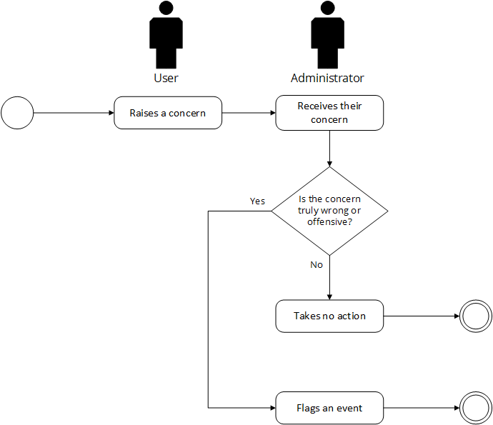

Post-conditions: Successful: The events were successfully flagged.
Failed: The events registered no flag input.

Special Requirements: NONE

